

**Rates for room rentals at the Alliance française Auckland**

**131 Remuera Road, Remuera, Auckland 1050**

Alliance Française Auckland is now offering rooms to rent for all your meeting and conference needs. We have 6 rooms that can each accommodate up to 15 people anytime from 9:00 am to 5:00 pm*.

Mettre les 6 photos des salles avec les tables en mode réunion.

Mettre l’équivalent de Wellington pour Wifi/kitchen/Coffee?

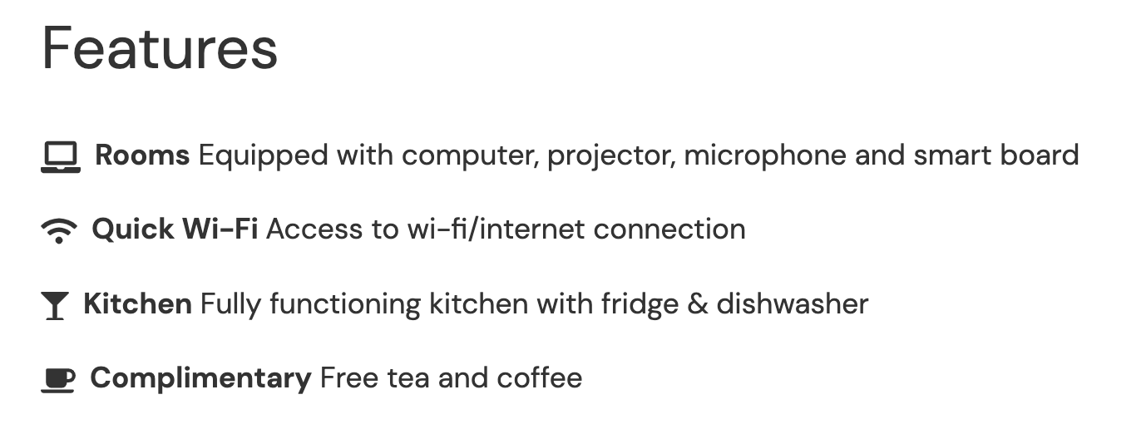

* there is plenty of free on-street parking available within Alliance Francaise Auckland perimeter

Please contact us to book your room:

Telephone: +64 (0)9 376 0009 or Email: information@alliance-francaise.co.nz

Invoices are sent once the booking is confirmed. Payments are accepted online via card or by bank transfer and have to be made before using the room.

| *All rates are excluding GST (+15%)\*\** | Number of people | ½ day  (4 hours) | Full day  (8 hours) |
| --- | --- | --- | --- |
| **Room 2 - 20 M2** | Up to 10 | $130 | $250 |
| **Room 3 -27 M2** | Up to 15 | $170 | $320 |
| **Room 4 - 26 M2** | Up to 15 | $170 | $320 |
| **Upstairs - Room 6 - 17m2** | Up to 5 | $80 | $140 |
| **Upstairs - Room A - 14m2** | Up to 3 | $70 | $120 |
| **Upstairs - Room B - 14m2** | Up to 3 | $70 | $120 |
| **Interactive White Board**  **(Laptop not provided)** |  | $ 20 | $ 40 |
| **Video Projector** |  | $ 10 | $ 20 |
| **Rent of any room for exams**  Incl. Marshall, room & administration fees (posting, photocopying) +> marshall?? | Up to 6 | $ 350 | $ 650 |

* For week-end and specific hours, please consult us

**10% discount for AFA members and not-for-profit organizations.

• **Photocopy**

| **Type** | **Cost (incl. GST)** |
| --- | --- |
| Single-sided black and white A4 | 5 cents per page |
| Double-sided black and white A4 | 10 centsper sheet |
| Single-sided colour A4 | 10 centsper sheet |
| Double-sided colour A4 | 20 cents per sheet |
| Single-sided black and white A3 | 30 cents per sheet |
| Double-sided black and white A3 | 50 cents per sheet |
| Single-sided colour A3 | 70 cents per sheet |
| Double-sided colour A3 | 1 $ per sheet |

**Option Breakfast :**

Coffee, tea, croissant, pain au chocolat, baguette, jam …

**$20 (incl GST) per people**

**Option Lunch :**

A selection of salads and sandwiches made with French baguette and savoury.

Little pastries and coffee.

**$25 (incl GST) per people**